Generic follow up email for all customers
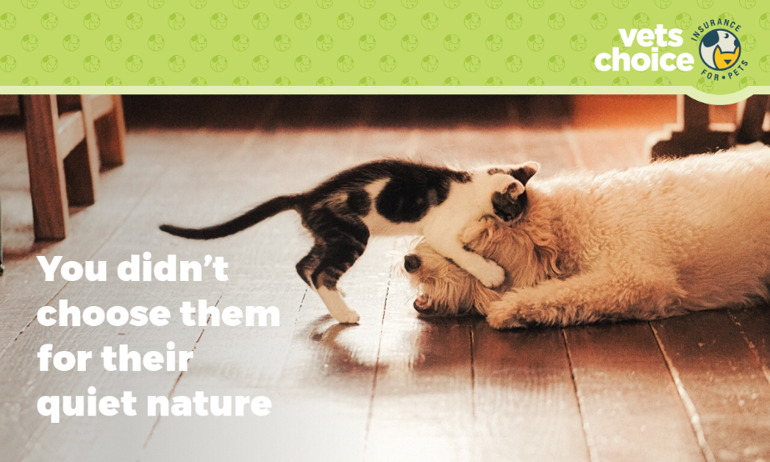
Dear (Valued Customer),
We hope you’re doing well, and we hope that (insert pet/pets name here) are being their happy selves and are keeping out of mischief!
Following your recent appointment, I would like to take the opportunity to ask if you’ve ever considered pet insurance?
Our partners, Vets Choice insurance for pets, offer the only pet insurance on the market endorsed by the Australian Veterinary Association. With no gap payments, three levels of cover and pre-approval for scheduled treatments, Vets Choice is a great option for protecting your pet.
To learn more about their pet insurance, and to make sure it’s right for you and your pet, visit vetschoice.net.au or call 1800 999 738.
Kind regards,
(Your practice name here)

DISCLAIMER
Insurance issued by Guild Insurance Ltd, ABN 55 004 538 863, AFSL 233791 and subject to terms, conditions and exclusions. This information is of a general nature only, please refer to the policy disclosure statement (PDS) for more details. For more information contact Guild Insurance on 1800 999 738.

