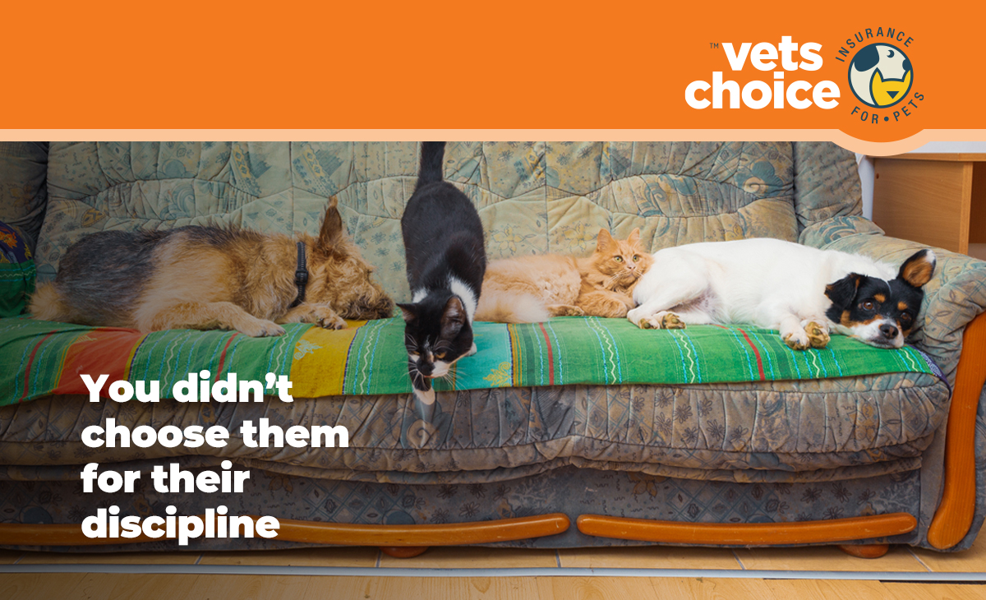
Hi (client name),
Nothing matters more to us than the health and safety of your pet. Your pet is more than just a companion, they’re a furry member of the family. They brighten your life, make you laugh and are always happy to see you.
However, unlike people, pets don’t always act the way they should. They get silly, eat things they shouldn’t and aren’t always predictable. And while you can’t predict if your pet is going to get injured or sick, you can prepare for it.
Pet insurance is a great option for pets and is often compared to private health insurance for people. Unfortunately, there is no Medicare equivalent for pets and in the case your pet gets sick, you could be facing a large unexpected vet bill, potentially costing thousands of dollars.
Pet insurance could remove the need for you to have to make a difficult decision. We encourage you to look for the best option for your pet, as the right pet insurance policy can help with unexpected bills.
Vets Choice is the only pet insurer endorsed by the Australian Veterinary Association, and offers different levels of cover to suit pet owner needs. They offer key features like pre-approval for scheduled treatments as well as cover for life and no gap-payments after paying your excess.
To find out more about Vets Choice and how they can protect your pet, click below.
For more information, visit vetschoice.net.au or call 1800 999 738.
Kind regards,
(Your practice)

